Internet Web and Programming Digital Assignment 1

Name: Om Ashish Mishra

Registration Number: 16BCE0789

Slot: E2

Questions: (Answer Any 2)

1. Design a webpage for an automobile company using the image mapping concept
2. Design an application form for collecting the biodata of students applying for PG course.
3. A Comparative study on internet protocols

Answer:

1.

The Code:

<!DOCTYPE>

<html>

<head>

<meta http-equiv="Content-Type" content="text/html; charset=iso-8859-1" />

<title>Automobile Company</title>

<style type="text/css">

<!--

footer{

background-color: rgba(0, 0, 51, 0.7);

}

.style1 {

font-size: 36px;

color: #FFFF00;

font-family: "Adobe Devanagari";

background-color: hsla(89, 43%, 51%, 0.3);

}

.om1 {

background-attachment: fixed;

background-repeat: no-repeat;

background-position: center;

word-spacing: normal;

color: #FF9900;

}

body{

background-image:url(OMBG.png);

background-repeat:no-repeat;

caption-side:bottom;

}

.style3 {

font-size: 24px;

font-weight: bold;

color: #00FF00;

}

.style5 {font-size: medium; color: #FFFFFF; }

.style6 {color: #FFFFFF}

-->

</style>

</head>

<body a link="#FFFFFF" vlink="#FF0000">

<h1 align="center" class="style1"> Welcome to the Top Automobile Company Website</h1>

<center>

<table width="428" border="1" cellspacing="1">

<caption class="om1">

<span class="style3">See What We Got More </span>

</caption>

<tr>

<th width="140" bgcolor="#000000" scope="col"><span class="style5"><a href="Assign2.html">Home</a></span></th>

<th width="152" bgcolor="#000000" scope="col"><span class="style5">About Us </span></th>

<th width="118" bgcolor="#000000" scope="col"><span class="style5">Contact Us </span></th>

</tr>

</table>

<p> <img src="am.jpg" width="1078" height="400" border="0" usemap="#Map">

<map name="Map">

<a href="https://www.bmw.in/en/index.html">

<area shape="poly" coords="866,74,874,74,889,71,904,73,919,76,930,84,940,96,946,109,944,125,935,135,927,137,915,142,895,148,876,148,863,142,849,135,840,125,839,115,841,103,843,94,851,86"></a>

<a href="https://www.marutisuzuki.com/">

<area shape="rect" coords="80,320,282,346"></a>

<a href="https://www.tvsmotor.com/">

<area shape="poly" coords="196,95,204,89,221,78,235,75,249,72,262,68,292,66,306,70,313,76,322,85,319,101,313,106,302,115,283,126,265,128,241,129,225,131,213,131,205,126,194,117,192,107"></a>

<a href="https://www.nissan.in/">

<area shape="rect" coords="840,316,1004,354"></a>

<a href="https://www.india.ford.com/">

<area shape="poly" coords="577,144,586,138,599,132,615,129,627,126,642,122,658,121,671,123,679,126,688,129,701,134,715,135,721,141,727,152,727,161,714,172,700,177,685,180,671,181,651,180,637,179,617,177,611,175,596,175,585,163,577,157"></a>

<a href="https://www.tatamotors.com/">

<area shape="poly" coords="29,108,40,99,54,92,71,92,92,94,108,95,123,104,126,116,118,125,105,133,106,147,120,148,129,149,135,158,141,168,135,166,117,166,95,169,79,171,53,167,37,167,20,168,15,153,14,147,23,146,31,146,45,145,34,122"></a>

<a href="https://www.honda2wheelersindia.com/">

<area shape="rect" coords="736,212,1020,255"></a>

<a href="https://www.toyotabharat.com/">

<area shape="poly" coords="533,53,597,57,674,56,746,56,794,56,809,67,813,76,808,83,735,84,681,80,648,82,609,80,557,85,534,85,509,78,505,66,512,61,519,52,536,52,549,52,558,52,566,52"></a>

<a href="http://www.mahindra.com/">

<area shape="poly" coords="336,173,333,158,352,157,367,152,364,134,378,120,391,118,405,119,412,119,426,121,443,124,444,132,447,137,447,147,454,156,466,162,481,163,484,174,482,178" href="#"></a>

<a href="https://www.heromotocorp.com/en-in/">

<area shape="rect" coords="92,226,259,261"></a>

<a href="https://www.suzukimotorcycle.co.in/">

<area shape="poly" coords="635,303,653,296,667,289,681,282,689,290,697,292,709,294,718,298,729,302,723,308,711,310,701,306,687,304,693,311,714,316,725,324,716,330,702,334,694,339,686,343,710,345,722,346,735,347,735,355,726,356,706,356,681,356,668,356,638,356,632,356,631,347,640,347,655,347,665,347,673,346,674,341,663,334,647,330,634,327,628,323,637,319,646,319,653,320,665,318,652,309"></a>

<a href="https://www.bajajauto.com/">

<area shape="poly" coords="325,302" href="#"><area shape="poly" coords="385,213,400,216,415,224,425,226,438,229,445,237,435,241,426,244,417,246,410,248,406,249,416,257,425,257,434,259,441,263,441,271,432,274,426,275,420,277,412,279,404,282,394,286,390,286,395,298,407,298,423,300,444,298,454,298,453,310,447,313,435,314,418,313,409,316,399,315,383,314,369,314,351,313,338,313,326,311,326,304,326,298,337,296,342,297,358,300,376,297,380,295,378,285,369,283,360,279,353,278,341,272,336,269,338,261,338,256,338,246,338,232,352,223,366,219,380,215"></a>

</map></p>

<footer><p class="style6">Posted by: Om Ashish Mishra</p>

<p class="style6">Contact information: <a href="omashish.mishra2016@vitstudent.ac.in">omashish.mishra2016@vitstudent.ac.in</a>.</p>

<h1 class="style6"> 16BCE0789 Om Ashish Mishra </h1>

</footer>

<div class="CopyRight Part 1"><strong>Digital Assignment 1</strong></div>

</center>

</body>

</html>

The Output:

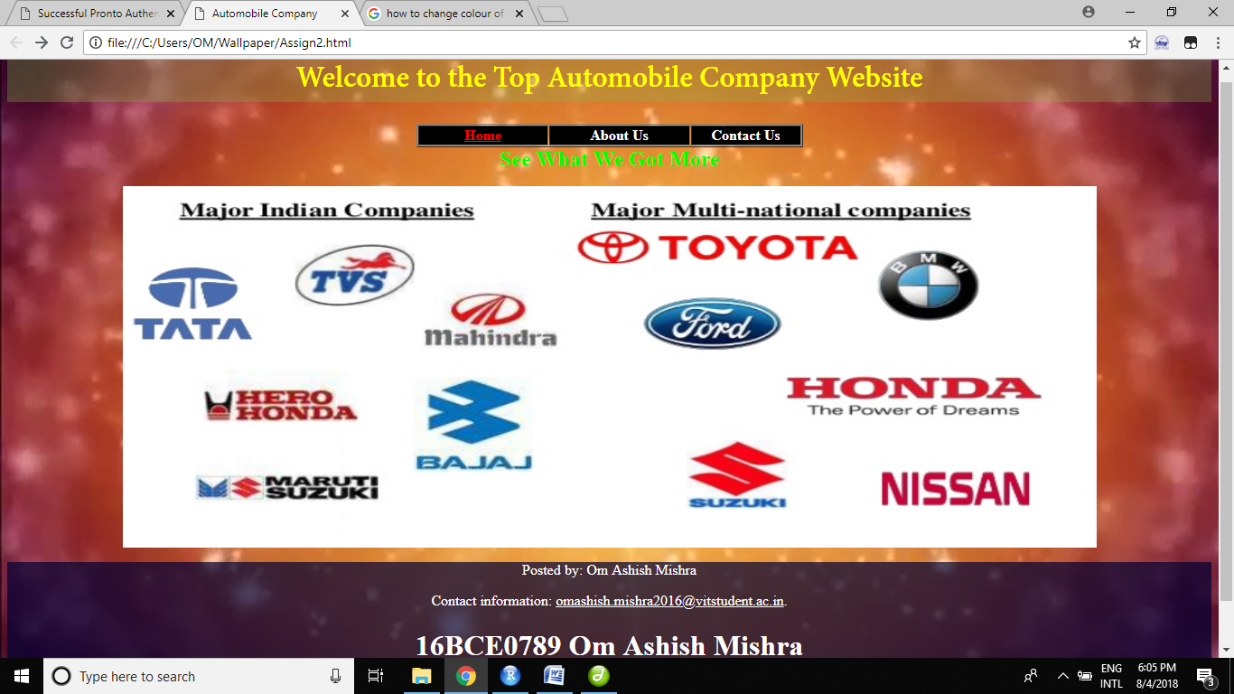

On Clicking any of the Images (suppose I click on Ford Company Logo), I am directed to their link:

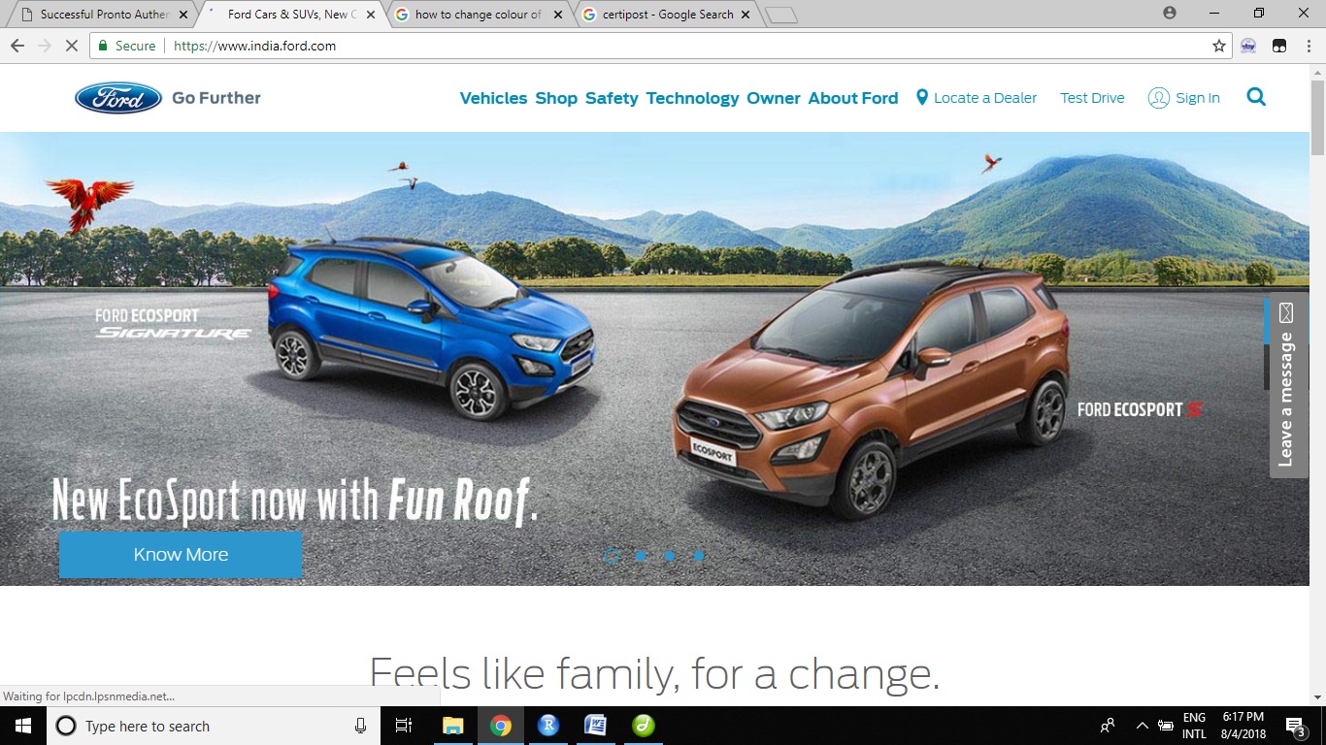

Example of the image mapping:-

<img src="am.jpg" width="1078" height="400" border="0" usemap="#Map">

<map name="Map">

<a href="https://www.bajajauto.com/">

<area shape="poly" coords="385,213,400,216,415,224,425,226,438,229,445,237,435,241,426,244,417,246,410,248,406,249,416,257,425,257,434,259,441,263,441,271,432,274,426,275,420,277,412,279,404,282,394,286,390,286,395,298,407,298,423,300,444,298,454,298,453,310,447,313,435,314,418,313,409,316,399,315,383,314,369,314,351,313,338,313,326,311,326,304,326,298,337,296,342,297,358,300,376,297,380,295,378,285,369,283,360,279,353,278,341,272,336,269,338,261,338,256,338,246,338,232,352,223,366,219,380,215"></a></map>

This is the code for the mapping the logo of bajaj to their website, the area shape holds the type of figure like radial for circle or rectangular or poly for irregular the coordinates. The image is am.jpg and we use Map concept into hyperlink the images.

2.

The Code:

<!DOCTYPE html>

<html>

<head>

<title>Form Demo</title>

<style type="text/css">

<!--

.heading1 {

font-family: "Courier New", Courier, monospace;

text-decoration: blink;

border-top-color: #9900CC;

border-right-color: #9900CC;

border-bottom-color: #9900CC;

border-left-color: #9900CC;

color: #FF0000;

}

body{

background-image:url(pg.jpg);

background-repeat:no-repeat;

background-color:#000033;

display:block;

}

#Layer1 {

position:absolute;

left:835px;

top:132px;

width:537px;

height:229px;

z-index:1;

}

#Layer2 {

position:absolute;

left:283px;

top:5px;

width:539px;

height:156px;

z-index:1;

}

.style7 {color: #CCFF66; font-size: 24px; }

.style8 {color: #FF0000}

.style9 {color: #00CC00}

#Layer3 {

position:absolute;

left:808px;

top:279px;

width:322px;

height:50px;

z-index:2;

}

#om{

background-color: rgba(0,0,50,0.4);

}

-->

</style>

</head>

<body>

<h1 align="center"><span class="style7"></span><img width="644" height="54" src="form_clip_image001.gif" alt="Registration for PG are Open!!"></h1>

<div align="center">

<img width="335" height="64" src="form_clip_image001_0001.gif" alt="Postgraduation!!">

</div>

<div id="om">

<form action="one.html" method="GET">

<div>

<label for="1st"><span class="style7">First Name:</span></label>

<span class="style7">

<input type="text" name="first name" placeholder="John" id="1st" required="true">

<label for="2nd">;Last Name:</label>

<input type="text" name="first name" placeholder="Smith" id="2nd" required="true">

<br>

<label for="1st">Father's Name:</label>

<input type="text" name="first name" placeholder="John" id="1st" required="true">

<br>

<label for="2nd">Mother's Name:&nbsp;</label>

<input type="text" name="first name" placeholder="Smith" id="2nd" required="true">

<br>

<label for="m">Male </label>

<input type="radio" name="Gender" id="m" value="MALE">

<label for="f">Female </label>

<input type="radio" name="Gender" id="f" value="FEMALE">

<label for="o">Other </label>

<input type="radio" name="Gender" id="o" value="OTHERS">

<br>

<label for="E">Email: </label>

<input type="email" name="email" id="E" placeholder="your email" required="true">

<label for="P">Password: </label>

<input type="password" name="password" id="P" placeholder="your password" required="true" pattern=".{5,10}"" title="Password must be between 5 and 10 charaters">

<br>

<label>Birthday:

<select>

<option value="Month">Month</option>

<option value="Month">1</option>

<option value="Month">2</option>

<option value="Month">3</option>

<option value="Month">4</option>

<option value="Month">5</option>

<option value="Month">6</option>

<option value="Month">7</option>

<option value="Month">8</option>

<option value="Month">9</option>

<option value="Month">10</option>

<option value="Month">11</option>

<option value="Month">12</option>

</select>

<select>

<option value="Day">Day</option>

<option value="Day">1</option>

<option value="Day">2</option>

<option value="day">3</option>

<option value="Day">4</option>

<option value="Day">5</option>

<option value="Day">6</option>

<option value="Day">7</option>

<option value="Day">8</option>

<option value="Day">9</option>

<option value="Day">10</option>

<option value="Day">11</option>

<option value="Day">12</option>

<option value="Day">13</option>

<option value="Day">14</option>

<option value="day">15</option>

<option value="Day">16</option>

<option value="Day">17</option>

<option value="Day">18</option>

<option value="Day">19</option>

<option value="Day">20</option>

<option value="Day">21</option>

<option value="Day">22</option>

<option value="Day">23</option>

<option value="Day">24</option>

<option value="Day">25</option>

<option value="Day">26</option>

<option value="day">27</option>

<option value="Day">28</option>

<option value="Day">29</option>

<option value="Day">30</option>

<option value="Day">31</option>

</select>

<select>

<option value="Year">Year</option>

<option value="Year">1997</option>

<option value="Year">1998</option>

<option value="Year">1999</option>

<option value="Year">2000</option>

<option value="Year">2001</option>

<option value="Year">2002</option>

<option value="Year">2003</option>

<option value="Year">2004</option>

<option value="Year">2005</option>

<option value="Year">2006</option>

<option value="Year">2007</option>

<option value="Year">2008</option>

<option value="Year">2009</option>

<option value="Year">2010</option>

<option value="Year">2011</option>

<option value="Year">2012</option>

<option value="Year">2013</option>

<option value="Year">2014</option>

<option value="Year">2015</option>

<option value="Year">2016</option>

<option value="Year">2017</option>

<option value="Year">2018</option>

</select>

</label>

</span>

<p class="style7">

<label for="label">Father's Occupation :</label>

<input type="text" name="first name2" placeholder="Engineer" id="label" required="true">

<label for="label2"><br>

Father's Salary:</label>

<input type="text" name="first name2" placeholder="Amount in Dollors" id="label2" required="true">

<br>

<label for="label">Mother's Occupation :</label>

<input type="text" name="first name2" placeholder="Doctor" id="label" required="true">

<br>

<label for="label2">Mother's Sallary:</label>

<input name="first name22" type="text" id="first name2" placeholder="Amount in Dollars" required="true">

<br>

<label for="label3"></label>

</p>

<p class="style7">

<label for="label6">Studied Previously From: </label>

<input name="" type="text" id="label6" value="" placeholder="your previous college name" required="true">

<label for="label7"><br>

Marks/CGPA

: </label>

<input name="password2" type="text" id="label7" placeholder="your CGPA" required="true" pattern=".{5,10}">

</p>

<p class="style7">

<label>Description of Why you want to join our college(SOP)

<br>

<textarea name="textarea" cols="100" rows="5"></textarea>

<br>

</label></p>

</div>

<br>

<div>

</div>

<div>

<label for="A"><span class="style8">I agree tp the terms and conditions</span> </label>

<input type="checkbox" id="A" required="true">

</div>

<input type="submit" name="submit">

<br>

<span class="style9">!6BCE0789 - Om Ashish Mishra </span>

</form>

</div>

</body>

</html>

The Output:

